To publich web app in Saritaappservice

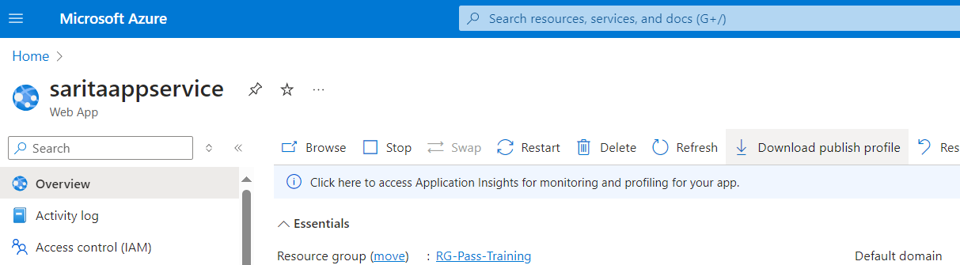

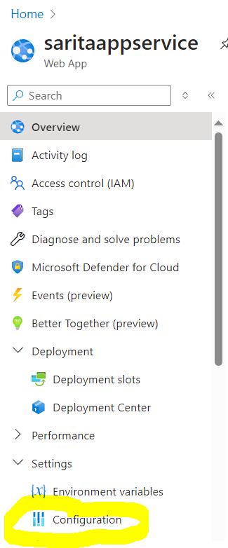

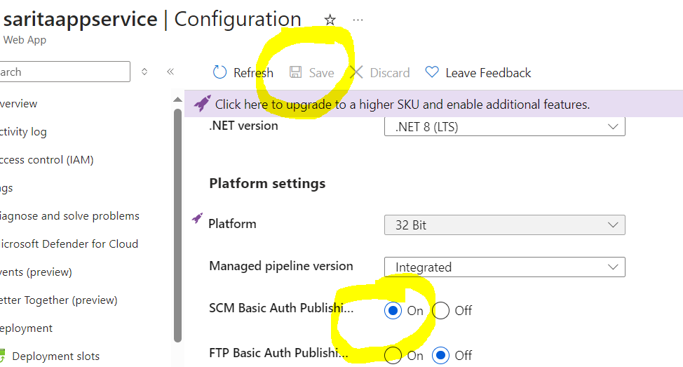

After download of file you copy userId and Password to connect in the step of publish

And paste it if required.